Article

Ancient reticulation and incomplete lineage sorting at the dawn of hornwort diversification and origin of the pyrenoid in the Carboniferous

Gabriel Peñaloza-Bojacá 1,*, J. Gordon Burleigh 6, Adaíses Maciel-Silva 1, D. Christine Cargill 2, David Bell 3, Emily B. Sessa 4, Fay-Wei Li 5, Stuart F. McDaniel 6, E. Christine Davis 6, Lorena Endara 7, N. Salazar Allen 8, Peter Schafran 9, Sahut Chantanaorrapint 10, Jeff Duckett 11, Silvia Pressel 11, Claudia Solís-Lemus 12, Karen Renzaglia 13* and Juan Carlos Villarreal A. 14,*

1. Departamento de Botânica, Universidade Federal de Minas Gerais, Brazil; [adaises.maciel@gmail.com](mailto:adaises.maciel@gmail.com)
2. Australian National Herbarium Canberra, Australia; [Chris.Cargill@dcceew.gov.au](mailto:Chris.Cargill@dcceew.gov.au)
3. Department of Botany, University of British Columbia, Canada; [DBell@rbge.org.uk](mailto:DBell@rbge.org.uk)
4. New York Botanical Garden, USA; [esessa@nybg.org](mailto:esessa@nybg.org)
5. Plant Biology Section, Cornell University, USA; [fl329@cornell.edu](mailto:fl329@cornell.edu)
6. Department of Biology, University of Florida, USA; [gburleigh@ufl.edu](mailto:gburleigh@ufl.edu), [stuartmcdaniel@ufl.edu](mailto:stuartmcdaniel@ufl.edu), [christine.davis@ufl.edu](mailto:christine.davis@ufl.edu)
7. Department of Biological Sciences, Clemson University, USA; [cendara@clemson.edu](mailto:cendara@clemson.edu)
8. Independent Researcher, Panama; [SalazarN@si.edu](mailto:SalazarN@si.edu)
9. Boyce Thompson Institute, USA; [ps997@cornell.edu](mailto:ps997@cornell.edu)
10. Department of Biology, Faculty of Science, Prince of Songkla University, Thailand; [sahut.c@psu.ac.th](mailto:sahut.c@psu.ac.th)
11. Natural History Museum, London, UK; [j.g.duckett@qmul.ac.uk](mailto:j.g.duckett@qmul.ac.uk), [s.pressel@nhm.ac.uk](mailto:s.pressel@nhm.ac.uk)
12. Wisconsin Institute for Discovery, University of Wisconsin-Madison, USA; [solislemus@wisc.edu](mailto:solislemus@wisc.edu)
13. Department of Plant Biology, Southern Illinois University Carbondale, USA
14. Département de Biologie, Université Laval, Canada

**\*** Correspondence: [gpenaloza.bojaca@gmail.com](mailto:gpenaloza.bojaca@gmail.com); [juan-carlos.villarreal-aguilar@bio.ulaval.ca](mailto:juan-carlos.villarreal-aguilar@bio.ulaval.ca), [renzaglia@siu.edu](mailto:renzaglia@siu.edu)

**Gabriel Peñaloza-Bojacá** and **J. Gordon Burleigh** contributed equally to this work

**SUPPLEMENTARY** **FIGURES**

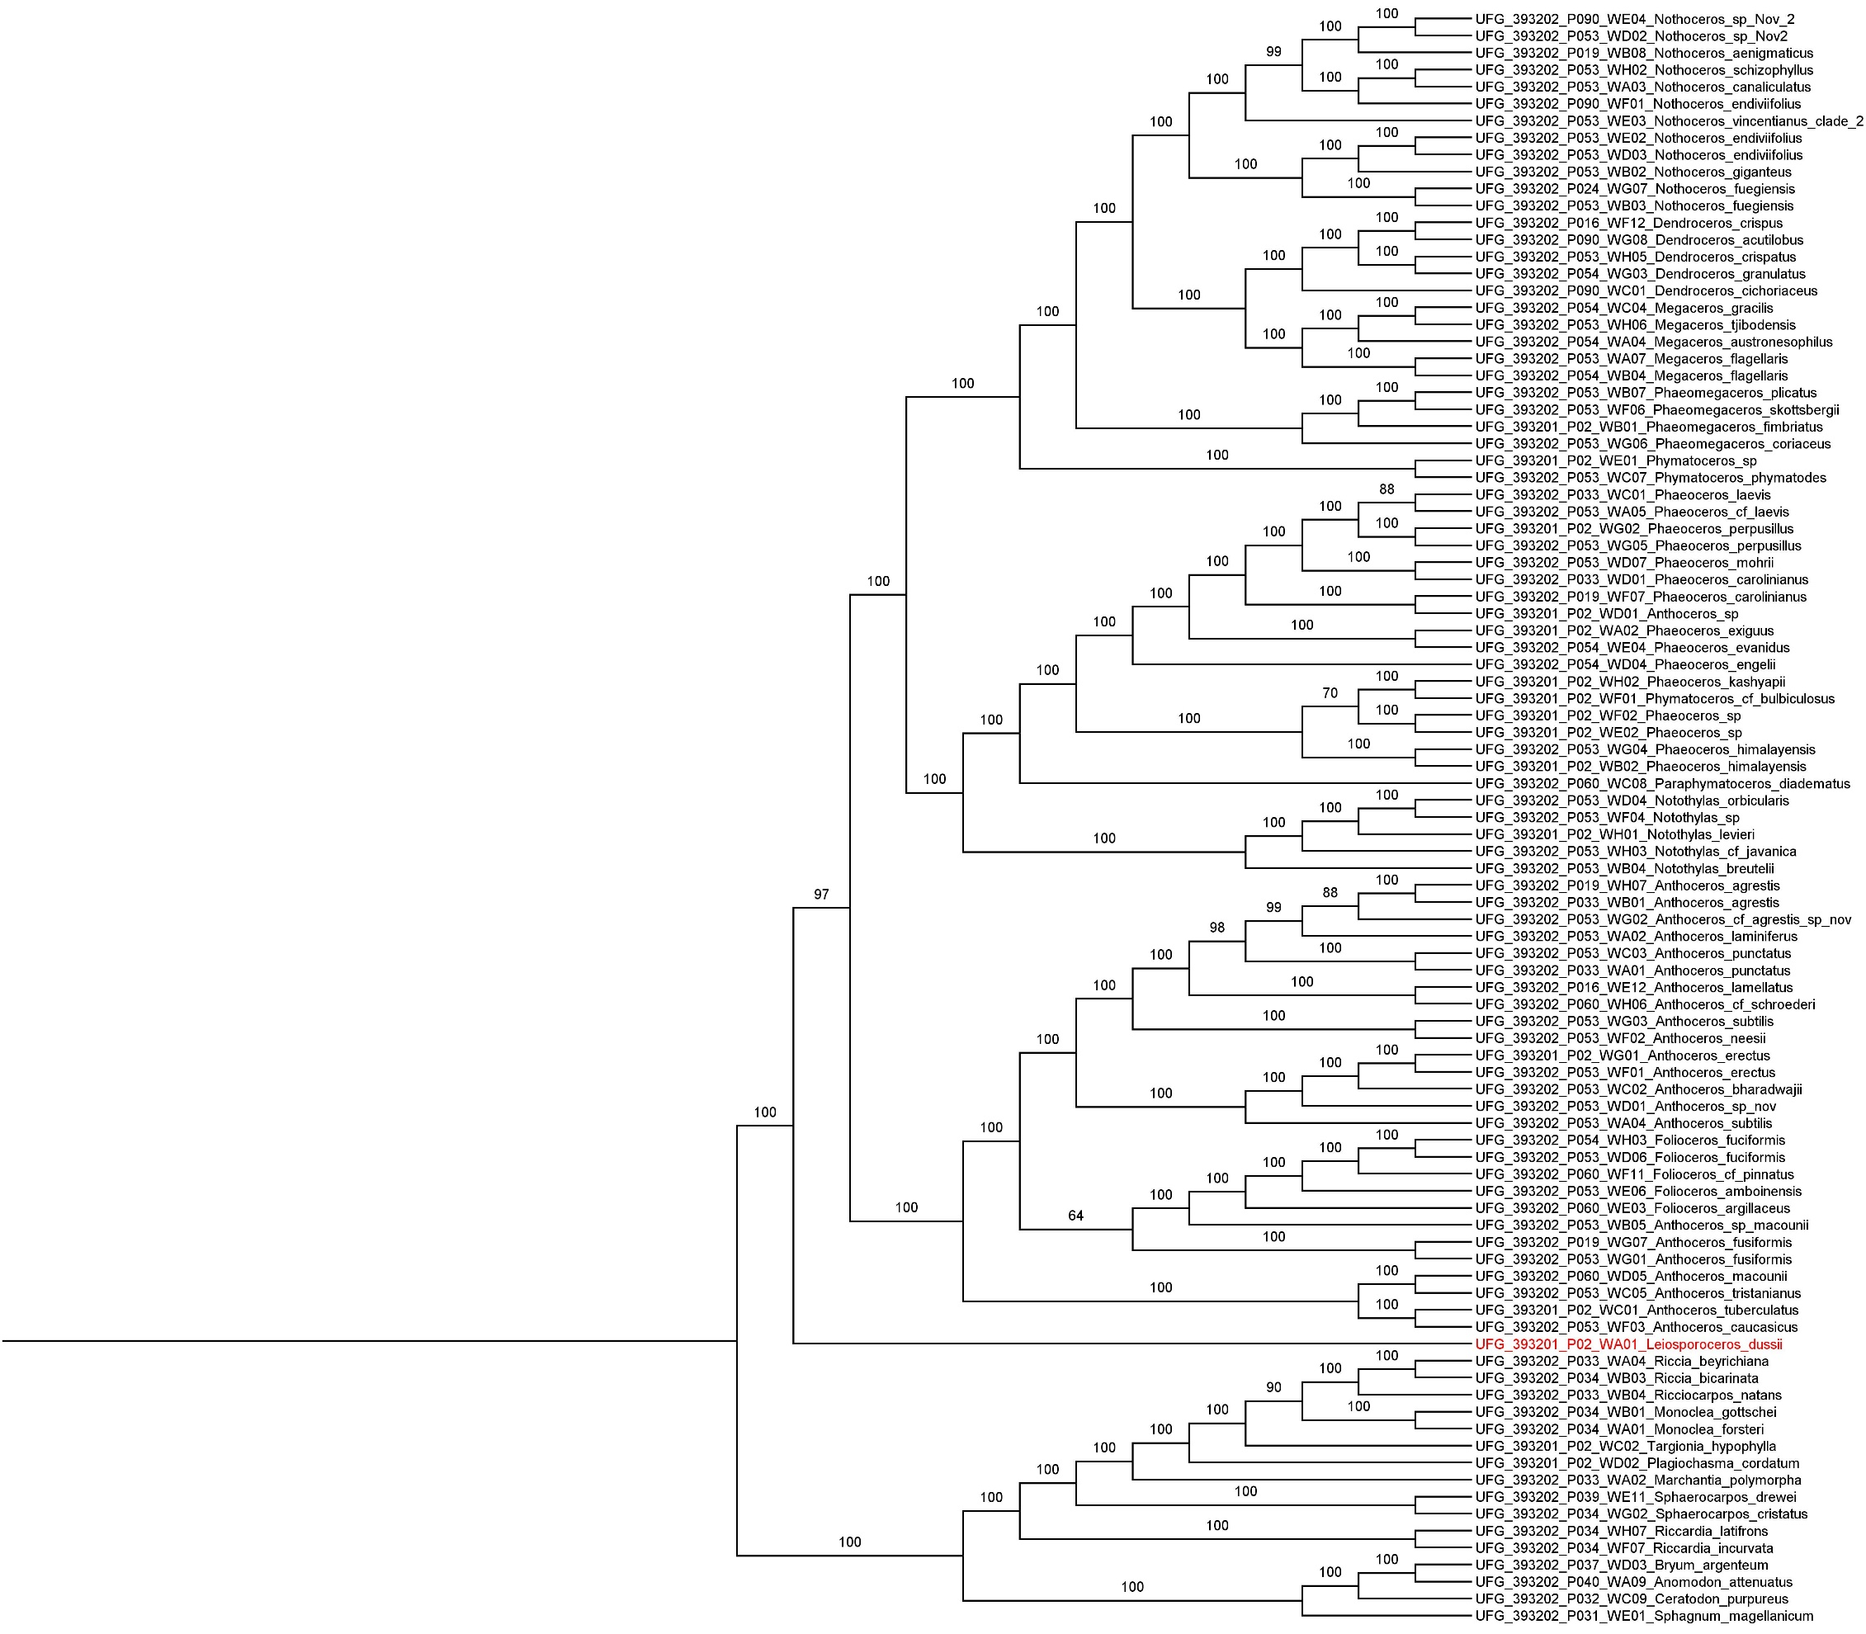

**Figure S1**. Hornworts phylogeny inferred with concatenation method (IQ-TREE) from nucleotide data showing bootstrap support with 234 genes.

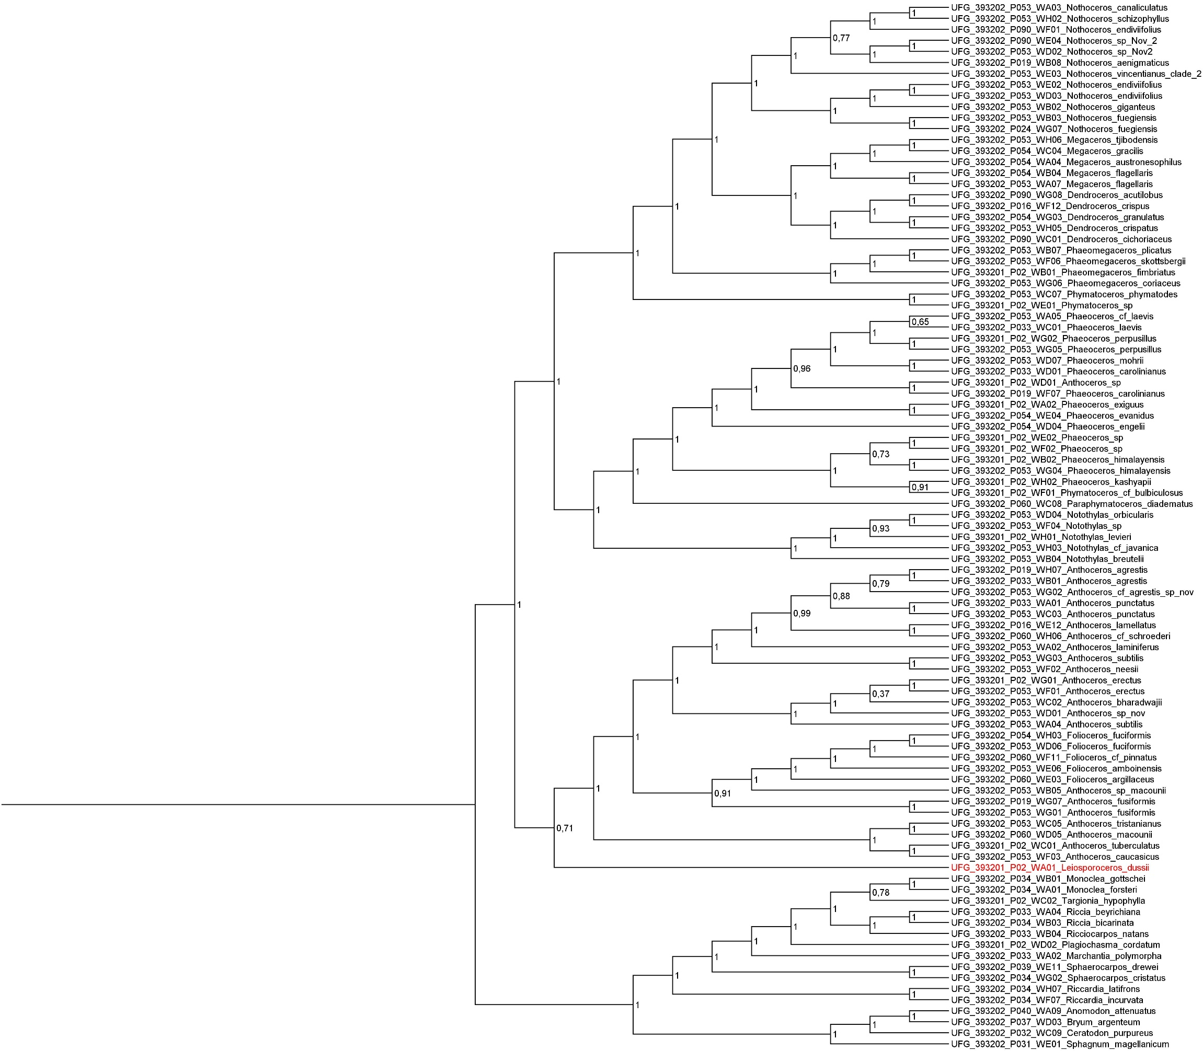

**Figure S2**. Hornworts phylogeny inferred with coalescence-based method (ASTRAL-III) from nucleotide data including the local posterior probability (lpp) values with 234 genes.

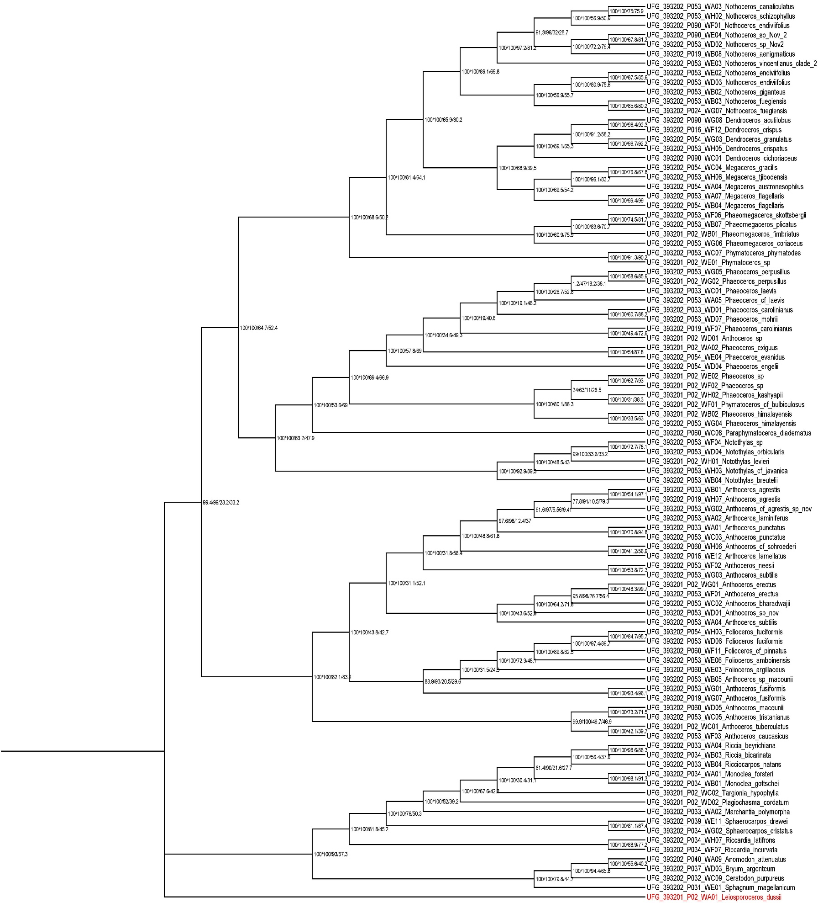

**Figure S3**. Hornworts phylogeny inferred with concatenation method (IQ-TREE) from nucleotide data with 195 genes (only genes with *Leiosporoceros dussii*), including bootstrap support and concordance values for each node outlined in Suppl. Table S4.

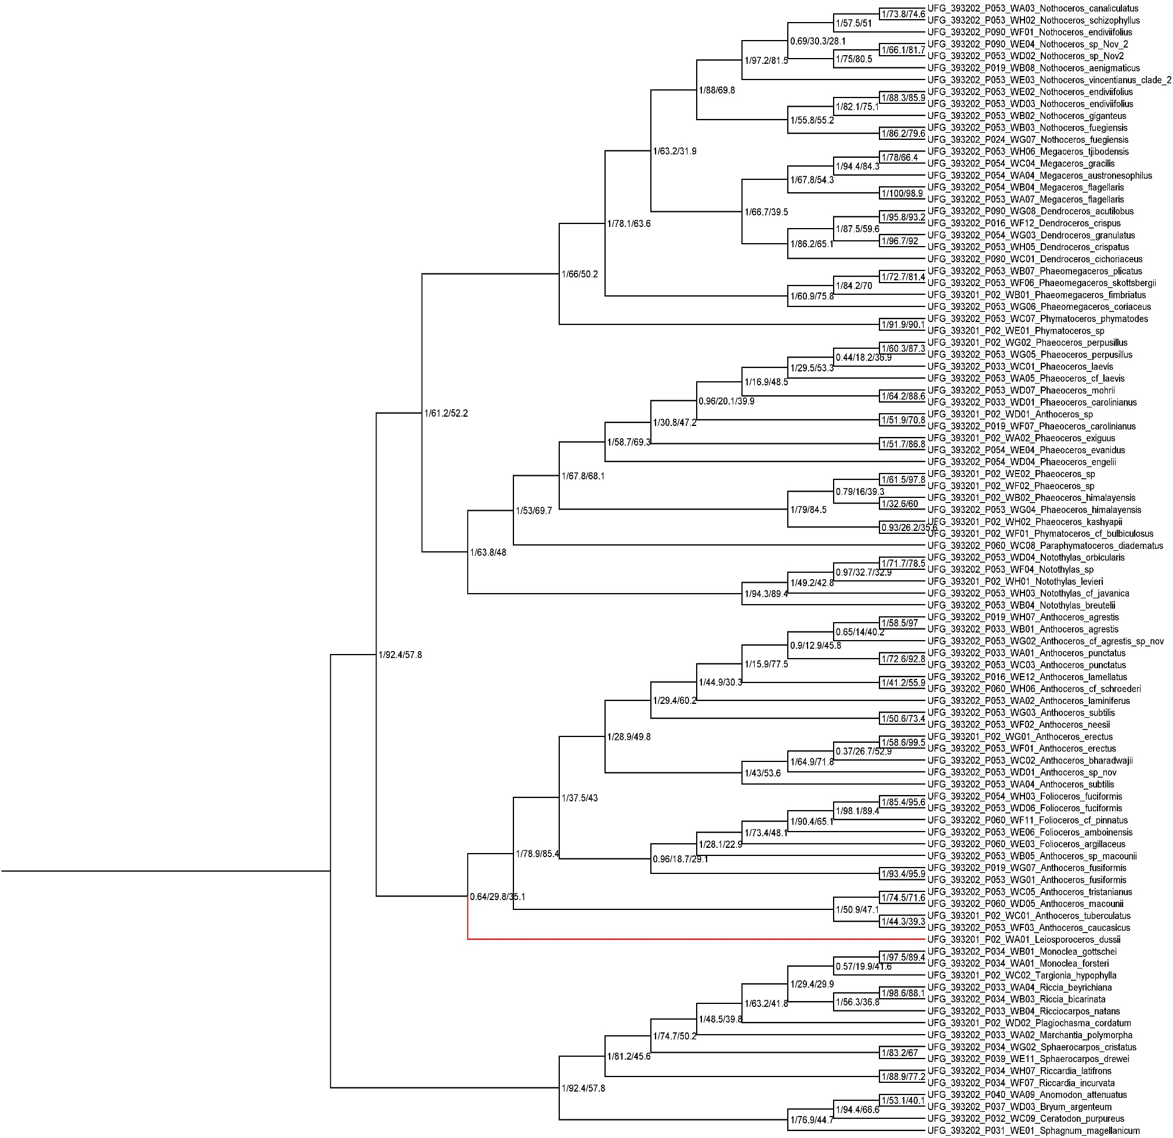

**Figure S4**. Hornworts phylogeny inferred with coalescence-based method (ASTRAL-III) from nucleotide data with 195 genes (only genes with *Leiosporoceros dussii*), including local posterior probability and concordance values for each node outlined in Suppl. Table S4.

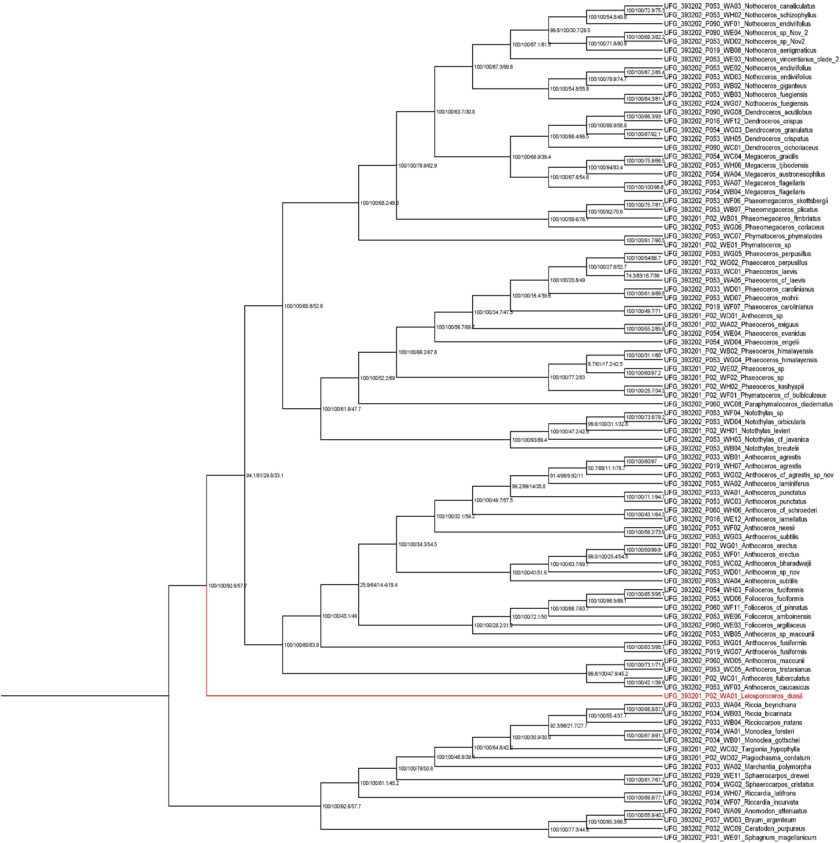

**Figure S5**. Hornworts phylogeny inferred with concatenation method (IQ-TREE) from nucleotide data with 234 genes including bootstrap support and concordance values for each node outlined in Suppl. Table S4.

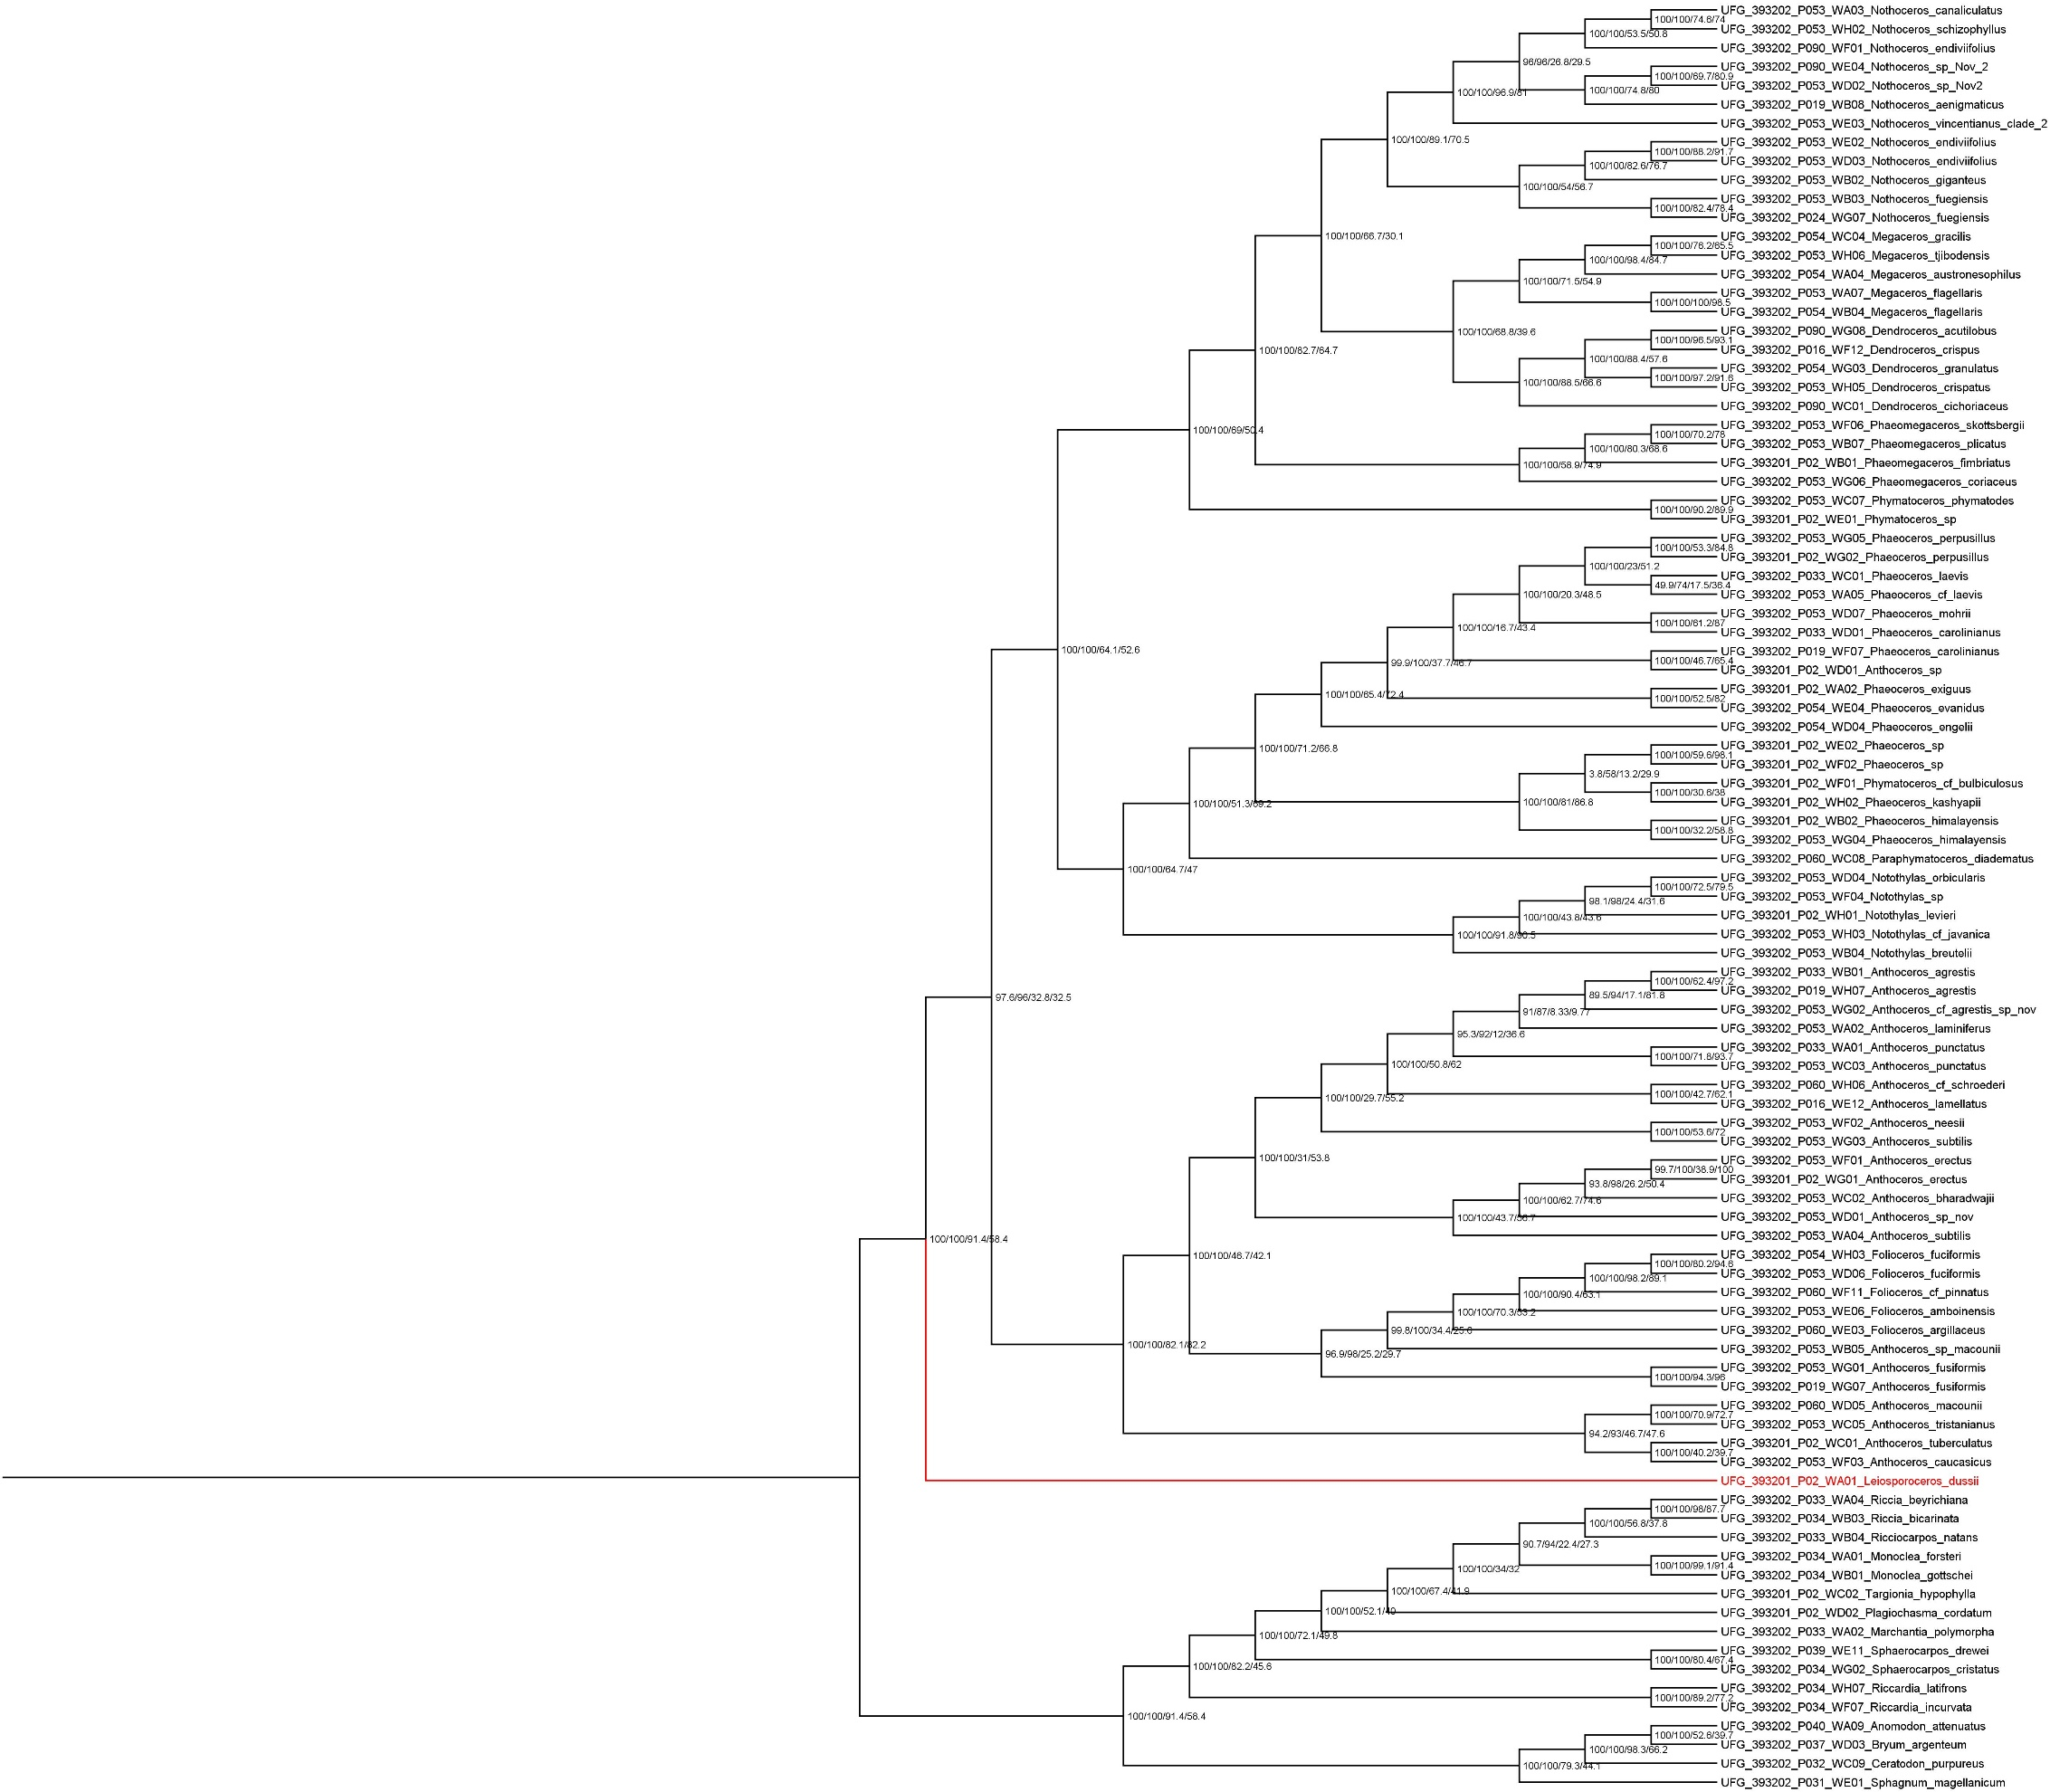

**Figure S6**. Hornworts phylogeny inferred with concatenation method (IQ-TREE) from nucleotide data with 161consistent genes including bootstrap support and concordance values for each node outlined in Suppl. Table S4.

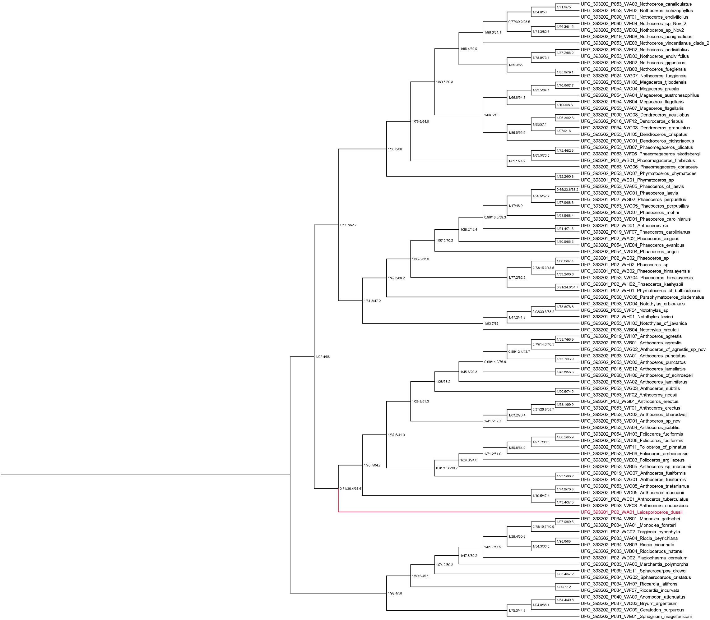

**Figure S7**. Hornworts phylogeny inferred with coalescence-based method (ASTRAL-III) from nucleotide data with 234 genes including local posterior probability values and concordance values for each node outlined in Suppl. Table S4.

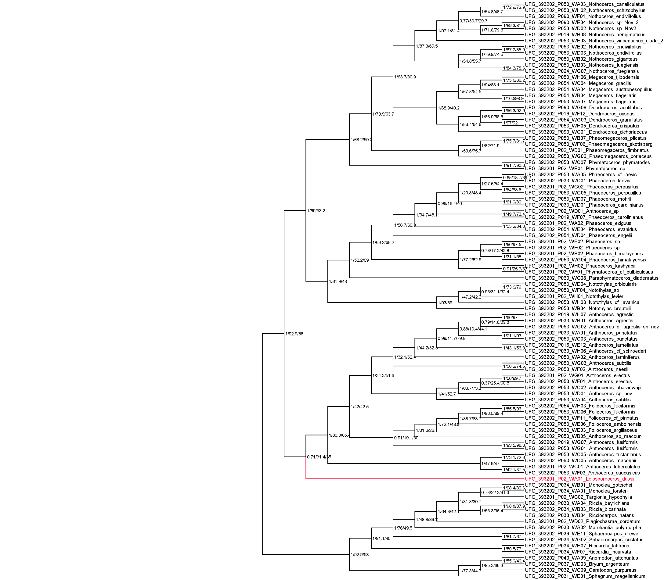

**Figure S8**. Hornworts phylogeny inferred from nucleotide data with 234 genes including local posterior probability values and concordance values for each node outlined in Suppl. Table S4. Base species tree inferred with coalescence-based method (ASTRAL-III) vs Base tree genes inferred with concatenation method (IQ-TREE).

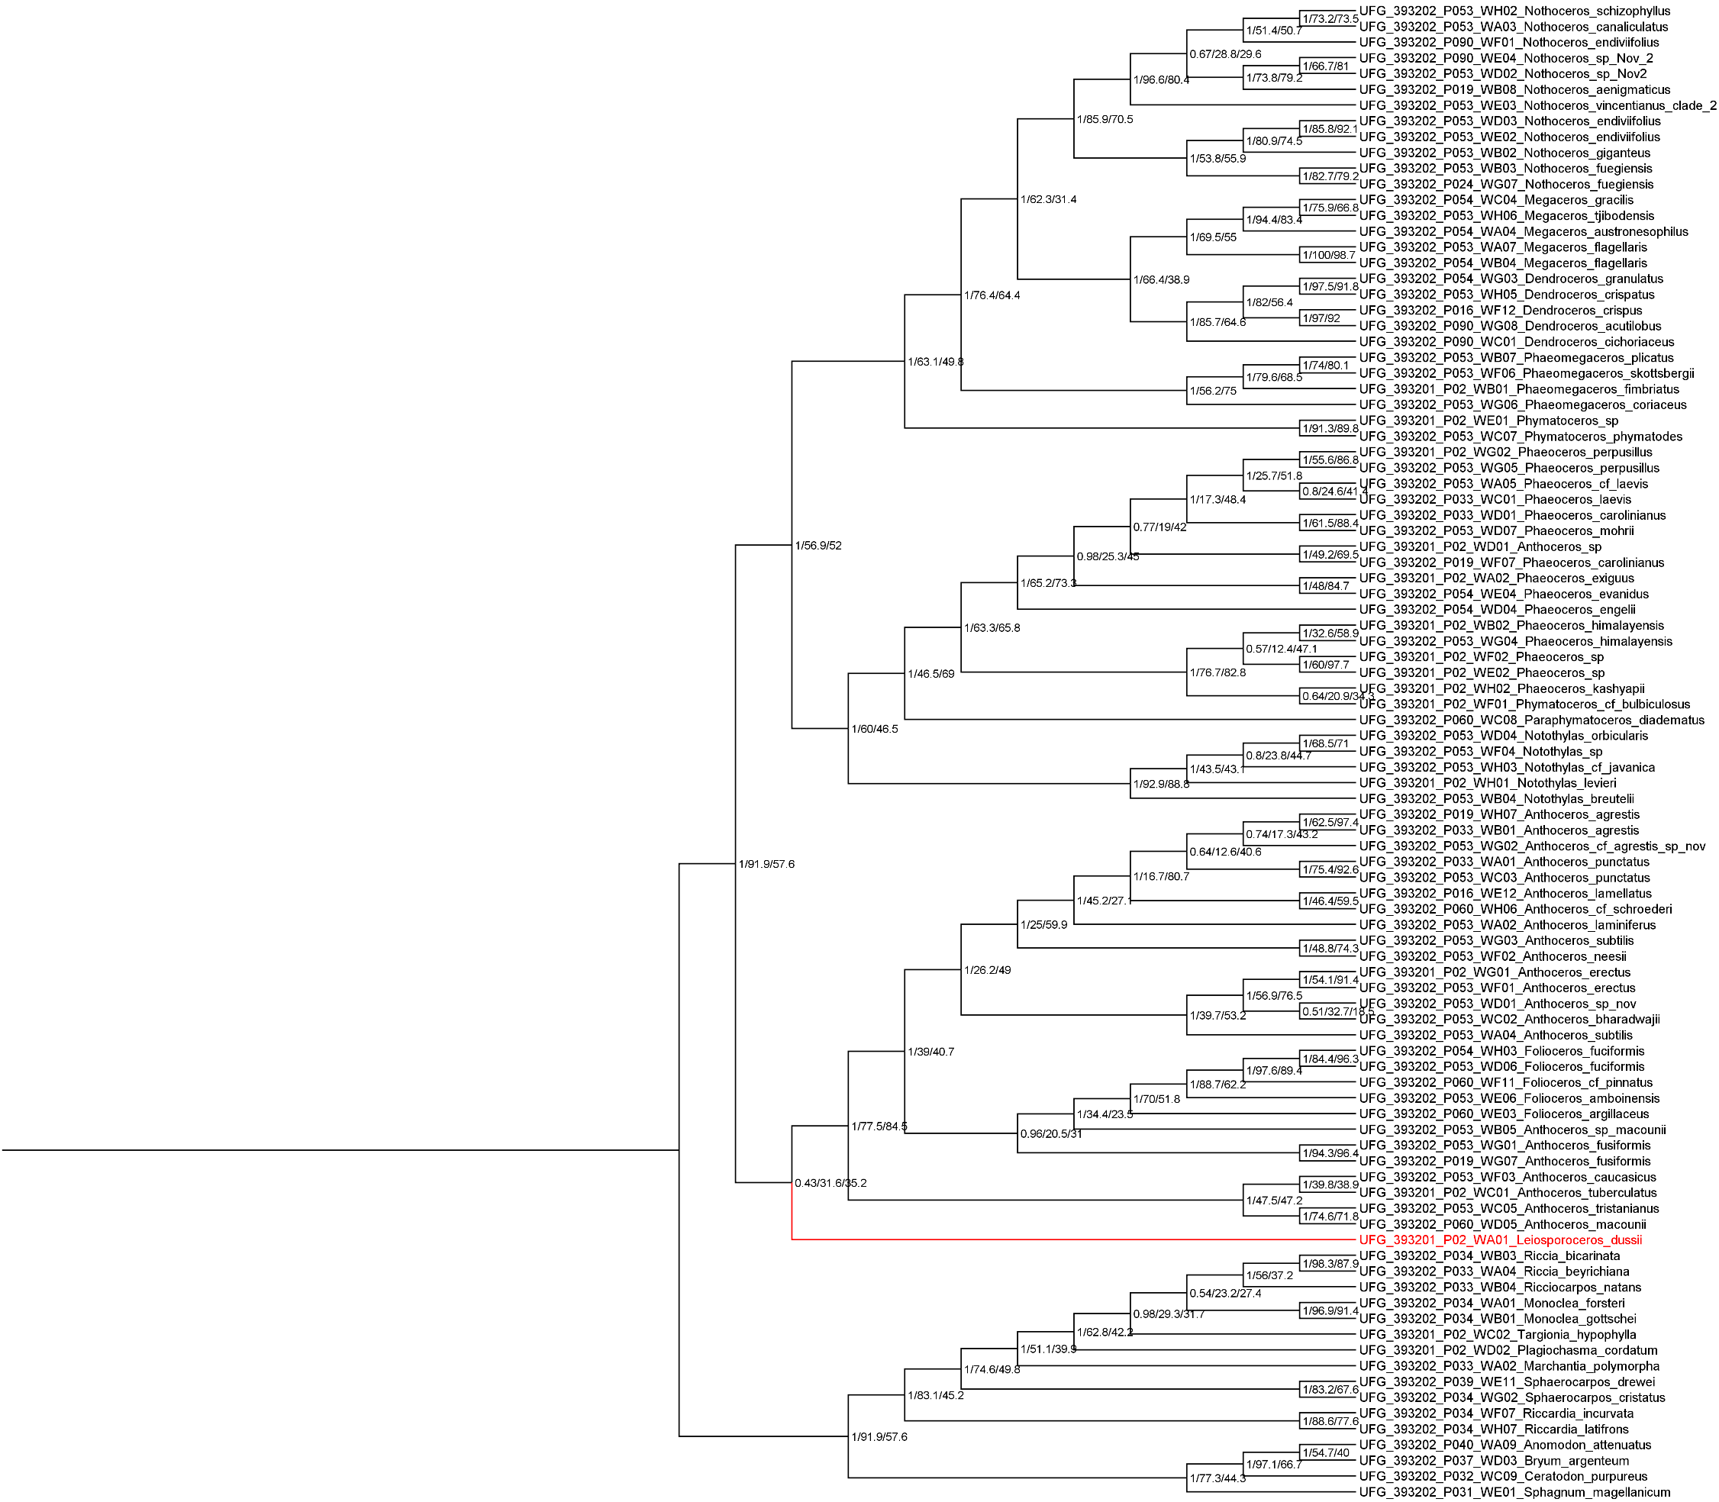

**Figure S9**. Hornworts phylogeny inferred with coalescence-based method (ASTRAL-III) from nucleotide data with 161 consistent genes including local posterior probability values and concordance values for each node outlined in Suppl. Table S4.

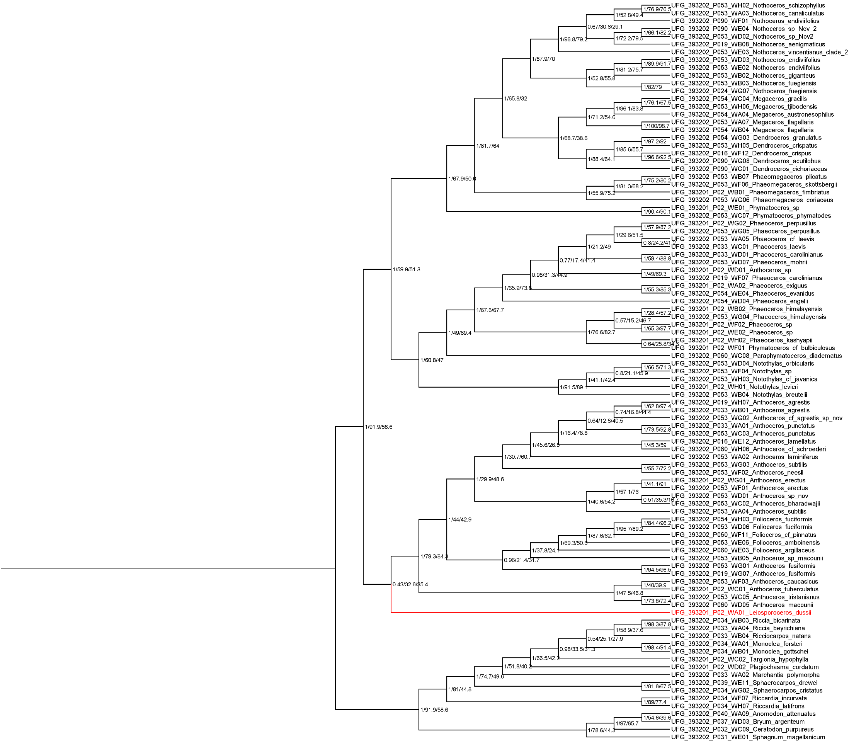

**Figure S10**. Hornworts phylogeny inferred from nucleotide data with 161 consistent genes including local posterior probability values and concordance values for each node outlined in Suppl. Table S4. Base species tree inferred with coalescence-based method (ASTRAL-III) vs Base tree genes inferred with concatenation method (IQ-TREE).

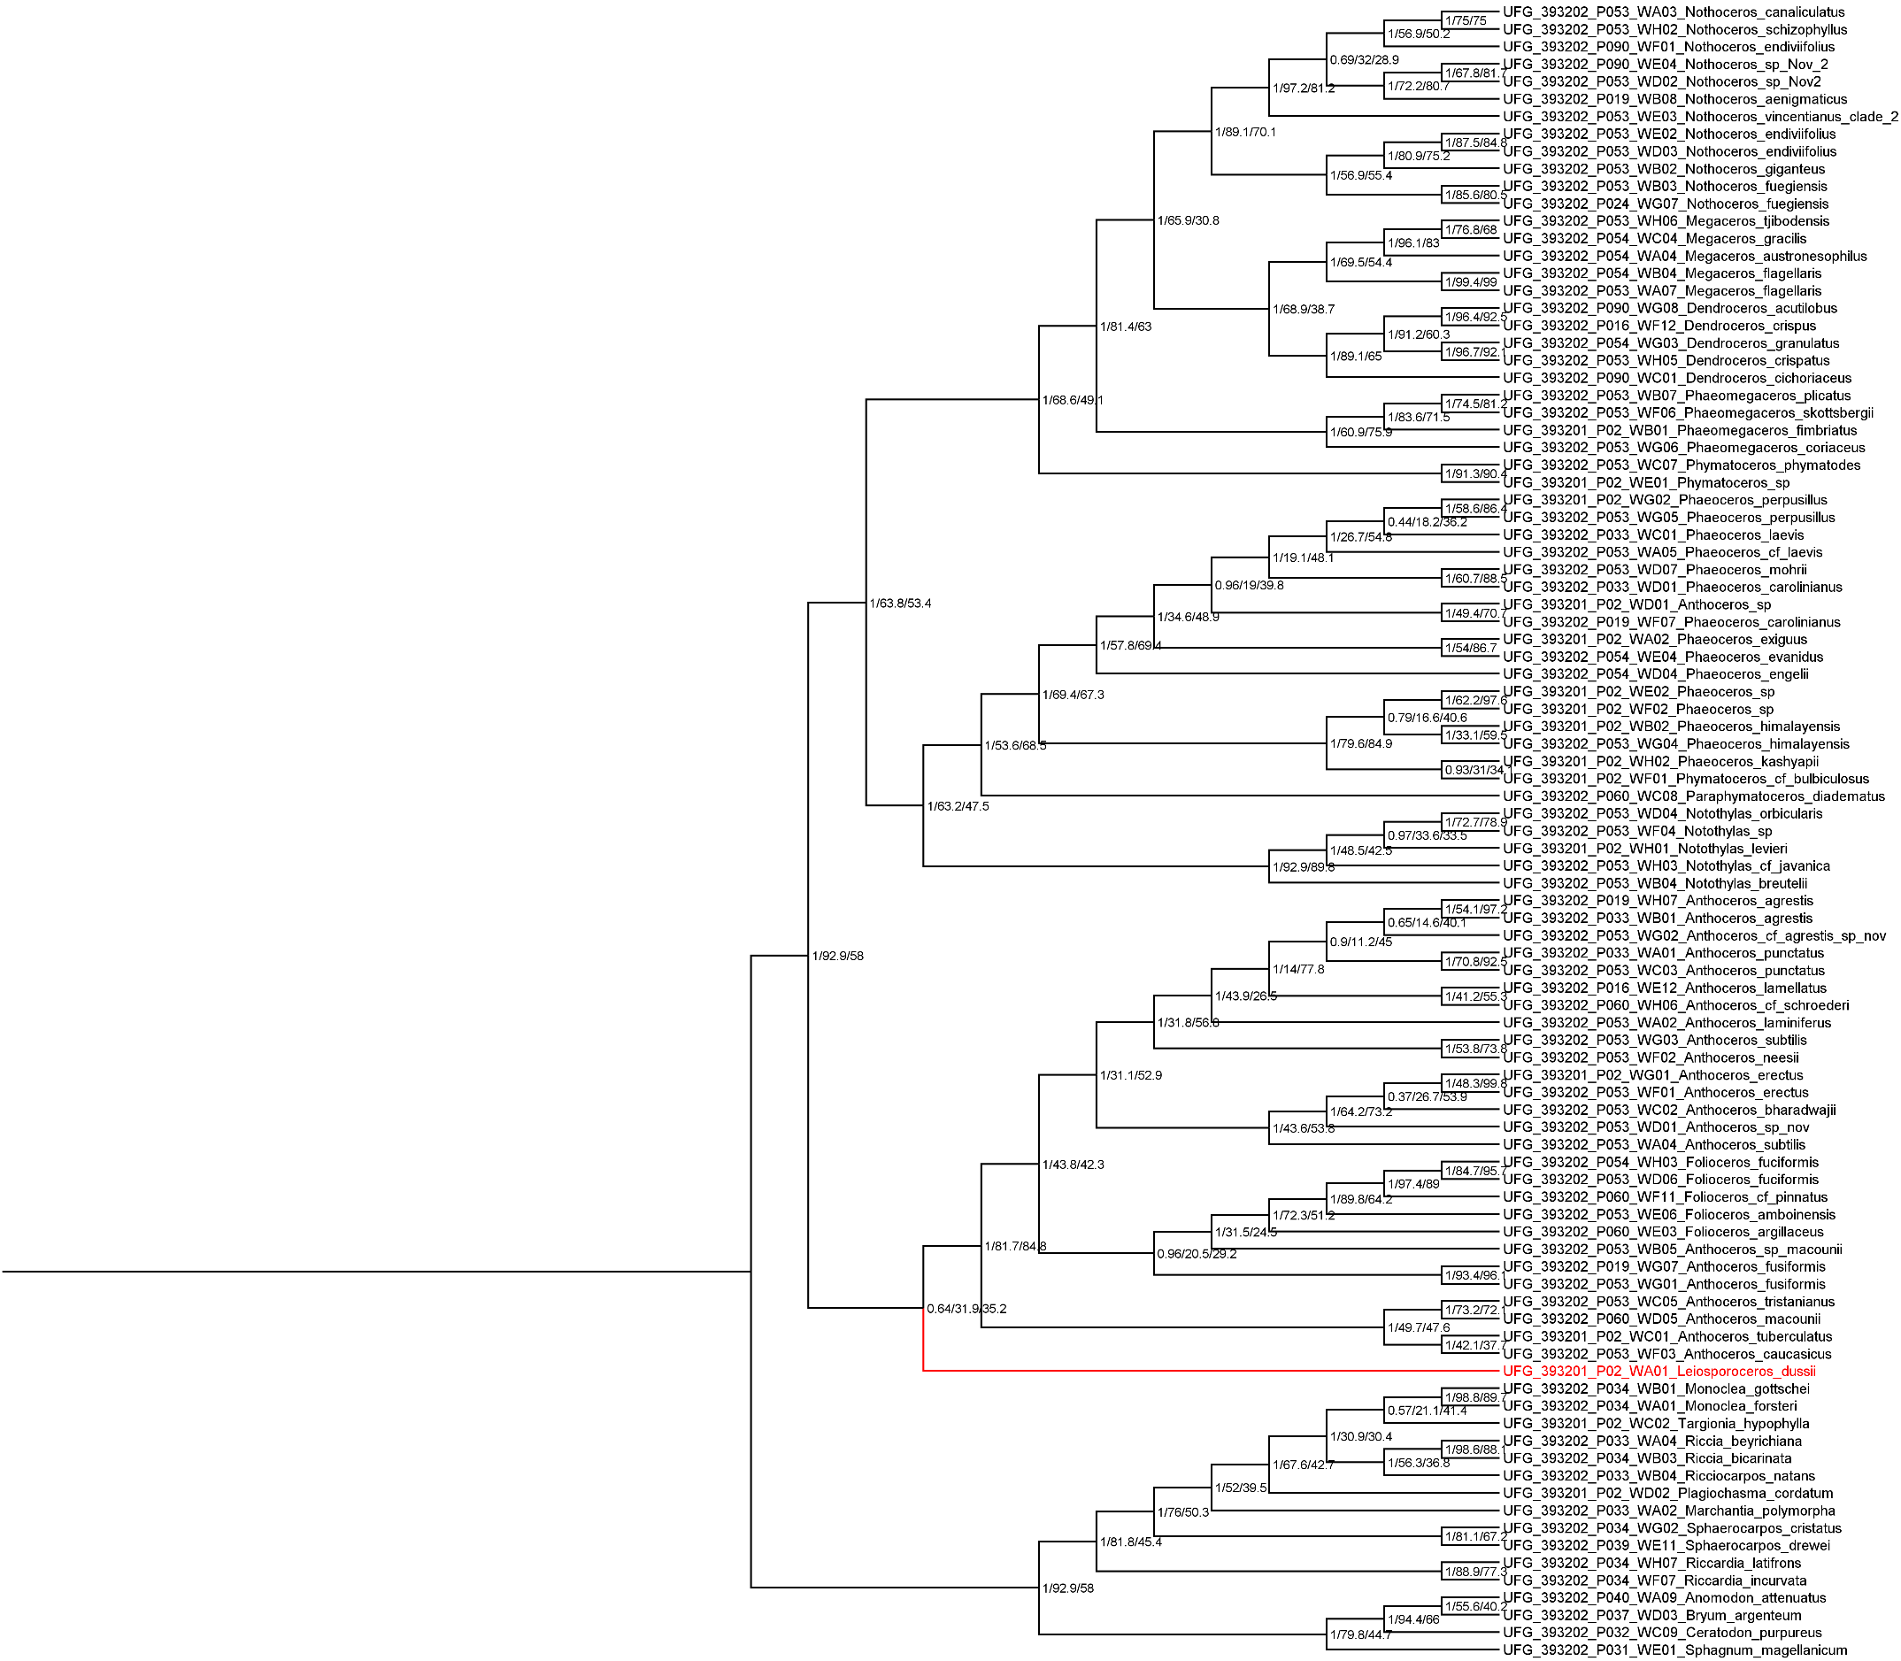

**Figure S11**. Hornworts phylogeny inferred from nucleotide data with 195 genes (only genes with *Leiosporoceros dussii*), including local posterior probability values and concordance values for each node outlined in Suppl. Table S4. Base species tree inferred with coalescence-based method (ASTRAL-III) vs Base tree genes inferred with concatenation method (IQ-TREE).

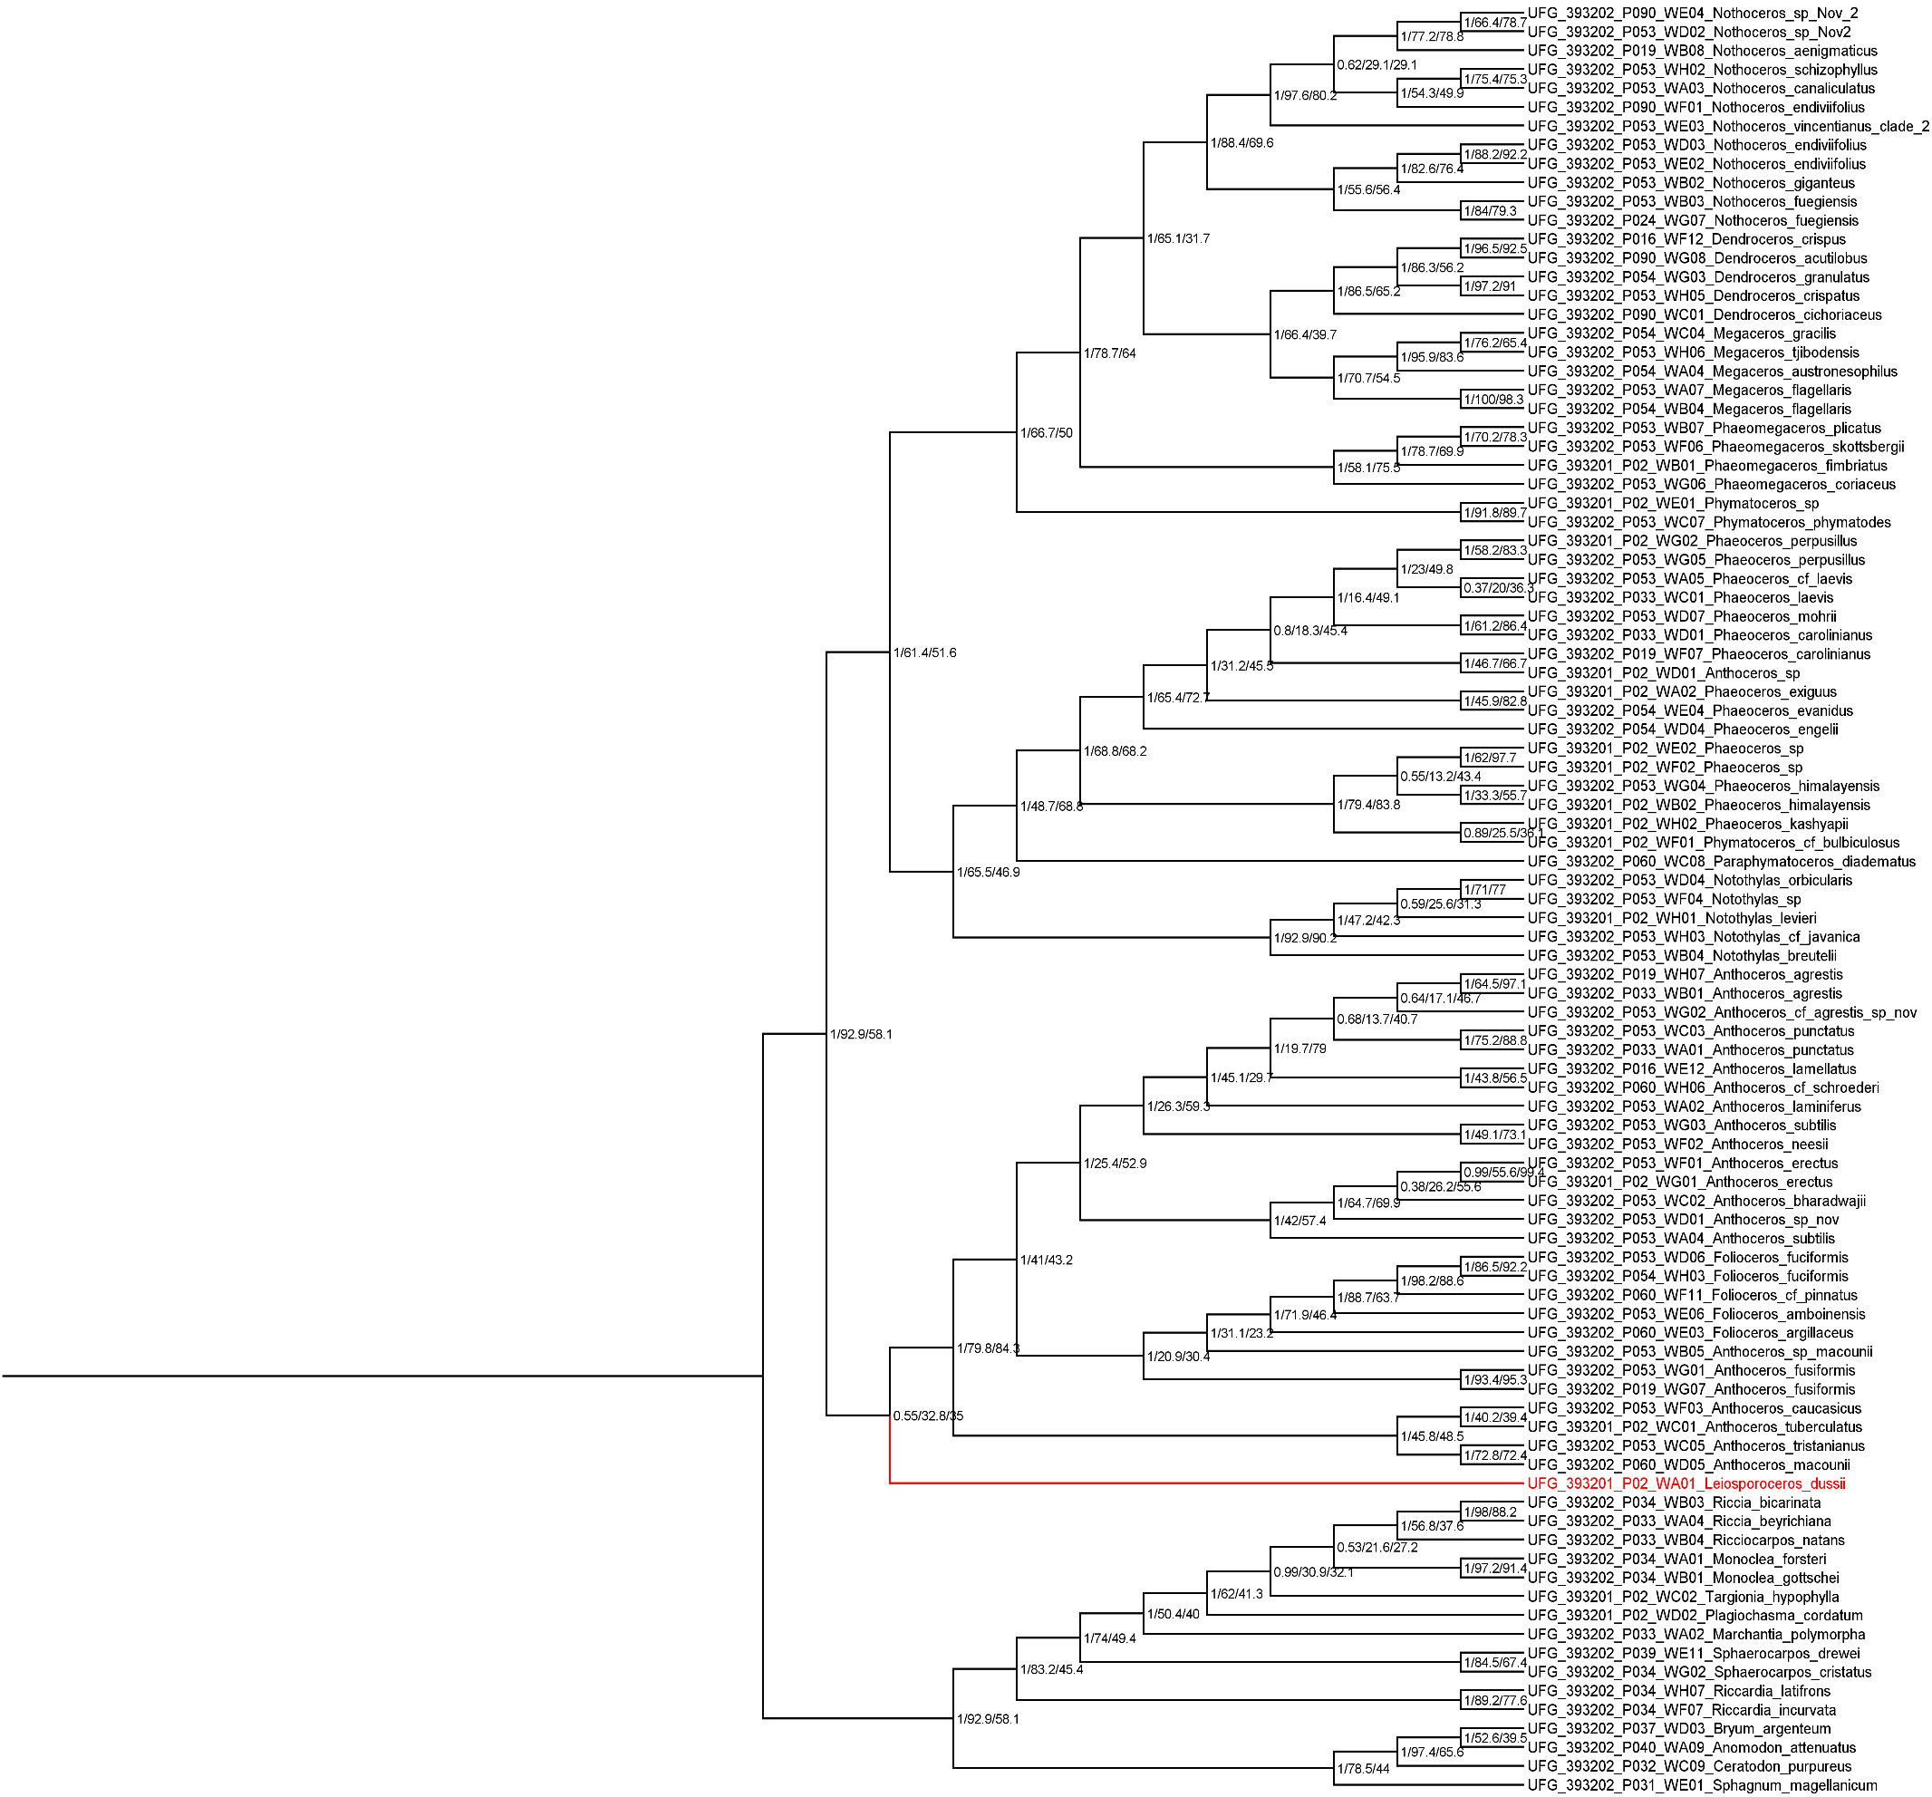

**Figure S12**. Hornworts phylogeny inferred with coalescence-based method (ASTRAL-III) from nucleotide data with 133 consistent genes (only genes with *Leiosporoceros dussii*), including local posterior probability values and concordance values for each node outlined in Suppl. Table S4.

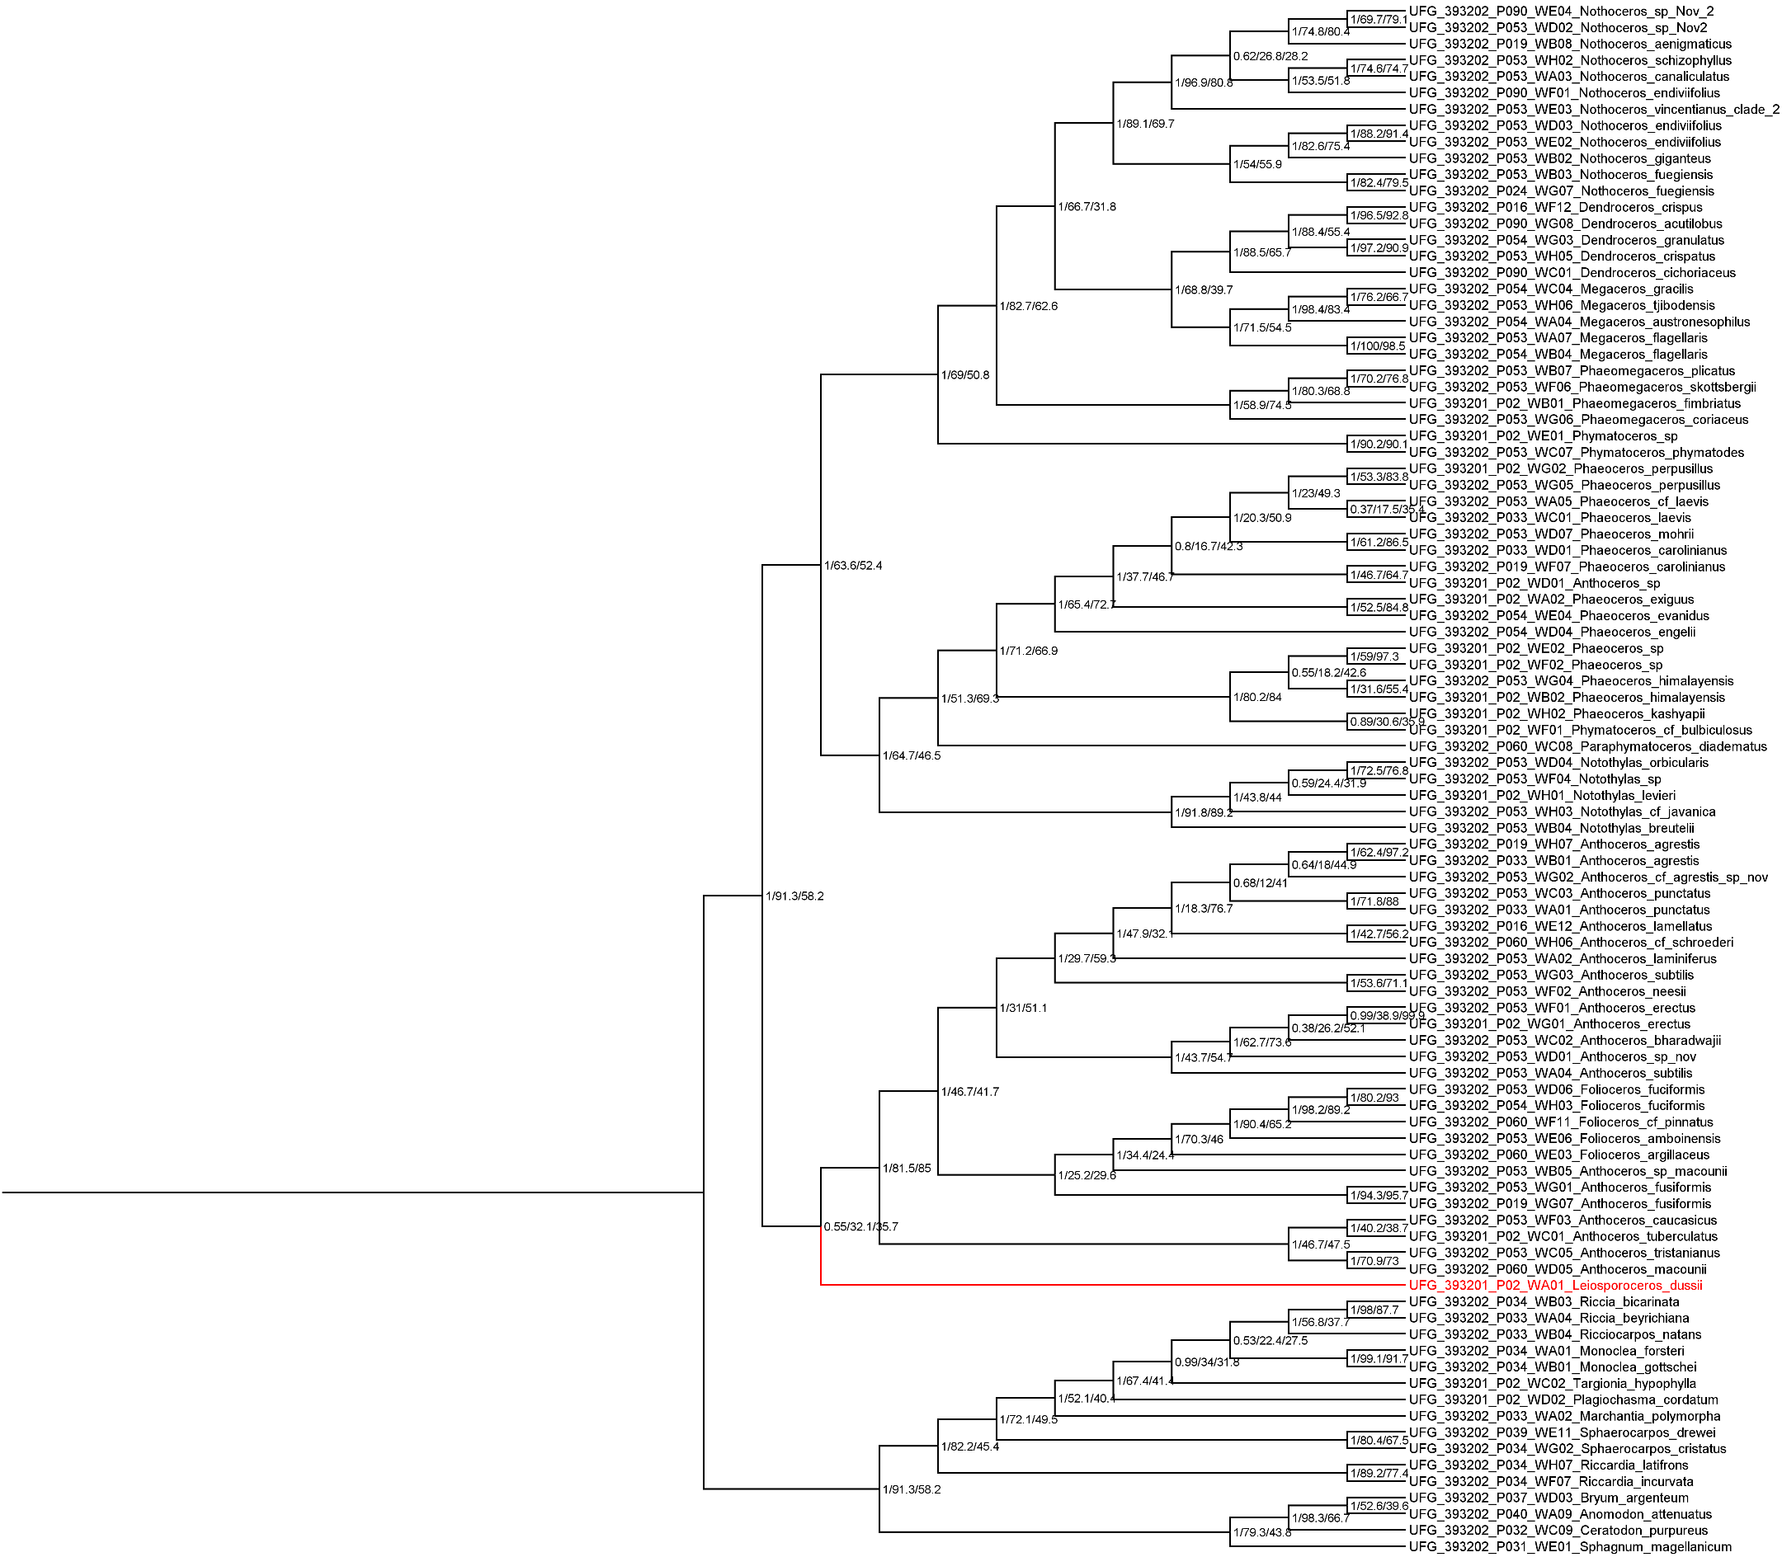

**Figure S13**. Hornworts phylogeny inferred from nucleotide data with 133 consistent genes (only genes with *Leiosporoceros dussii*), including local posterior probability values and concordance values for each node outlined in Suppl. Table S4. Base species tree inferred with coalescence-based method (ASTRAL-III) vs Base tree genes inferred with concatenation method (IQ-TREE).



**Figure S14**. Estimates of ancient reticulate evolution (SNaQ) from all hornwort genera using 234 genes and hmax = 3 (number of hybridizations). Estimated network based on T1 topology (*Leiosporoceros* sister to all hornworts) with best scores across hybrid values (-Ploglik).

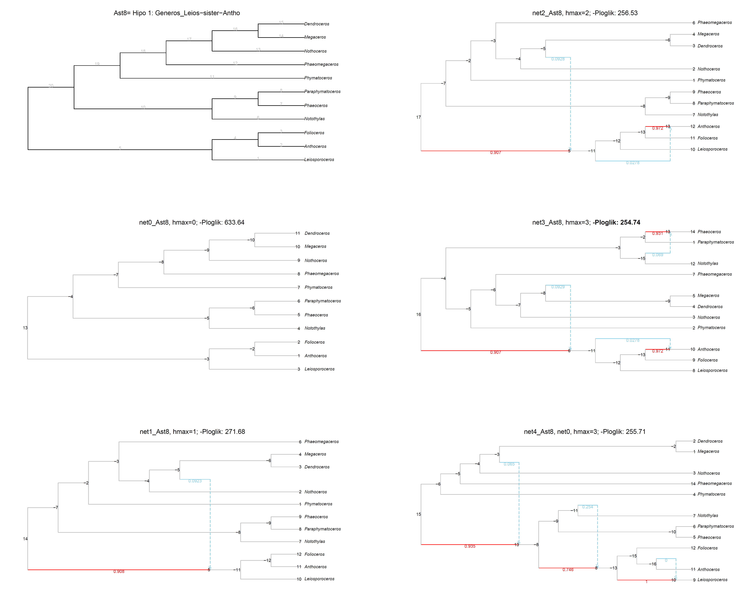

**Figure S15**. Estimates of ancient reticulate evolution (SNaQ) from all hornwort genera using 234 genes and hmax = 3 (number of hybridizations). Estimated network based on T2 topology (*Leiosporoceros* sister to Anthocerotaceae) with best scores across hybrid values (-Ploglik).



**Figure S16**. Plot scores between hybrid values. Hmax are the hybridization numbers (0-3). |It was based on T1 topology (*Leiosporoceros* sister to all hornworts).



**Figure S17**. Plot scores between hybrid values. Hmax are the hybridization numbers (0-3). |It was based on T2 topology (*Leiosporoceros* sister to Anthocerotaceae).

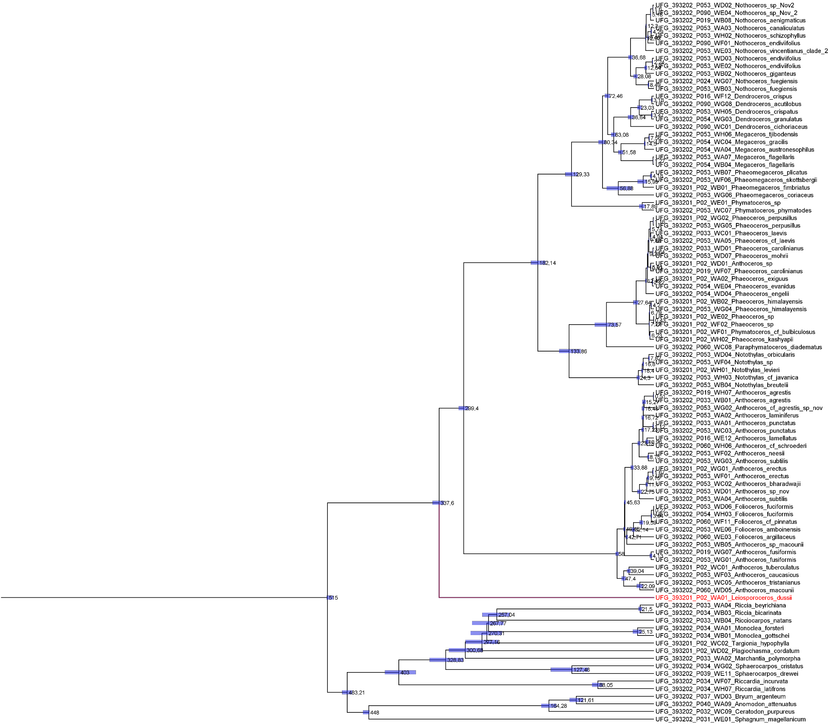

**Figure S18**. Divergence time estimates for hornwort genera using the concatenation method (IQ-TREE) based on 234 nuclear genes. Node heights represent mean ages, and bars indicate the 95% highest posterior density intervals.

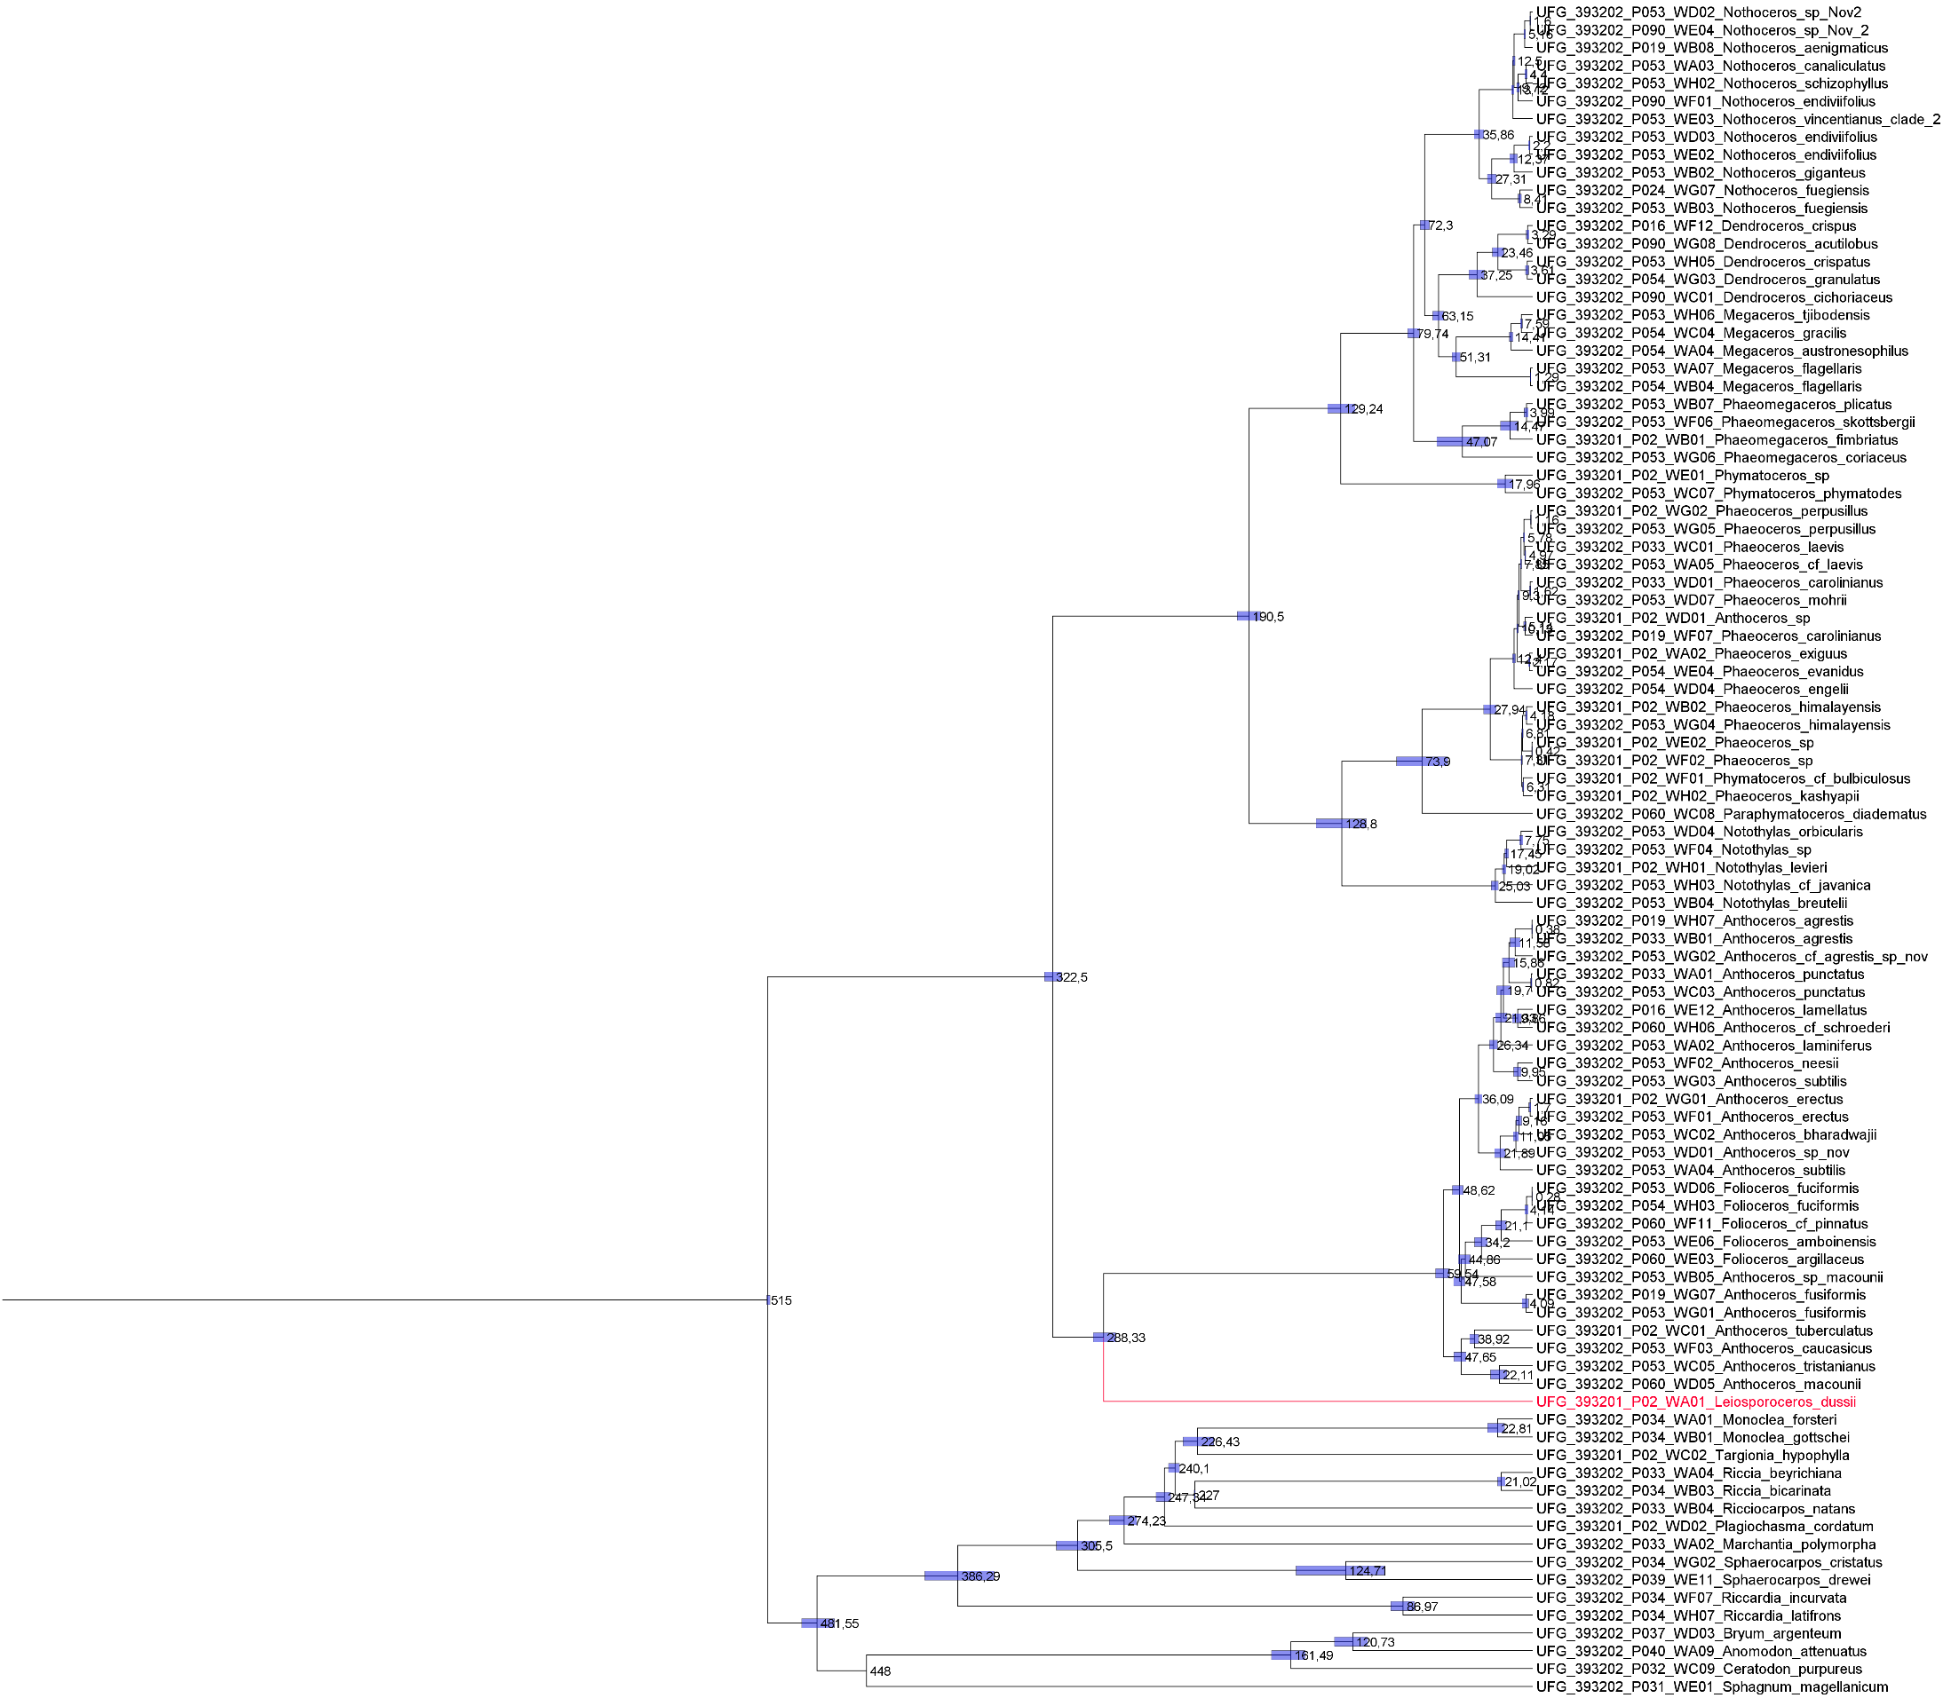

**Figure S19**. Divergence time estimates for hornwort genera using the coalescence-based method (ASTRAL-III) based on 234 nuclear genes. Node heights represent mean ages, and bars indicate the 95% highest posterior density intervals.

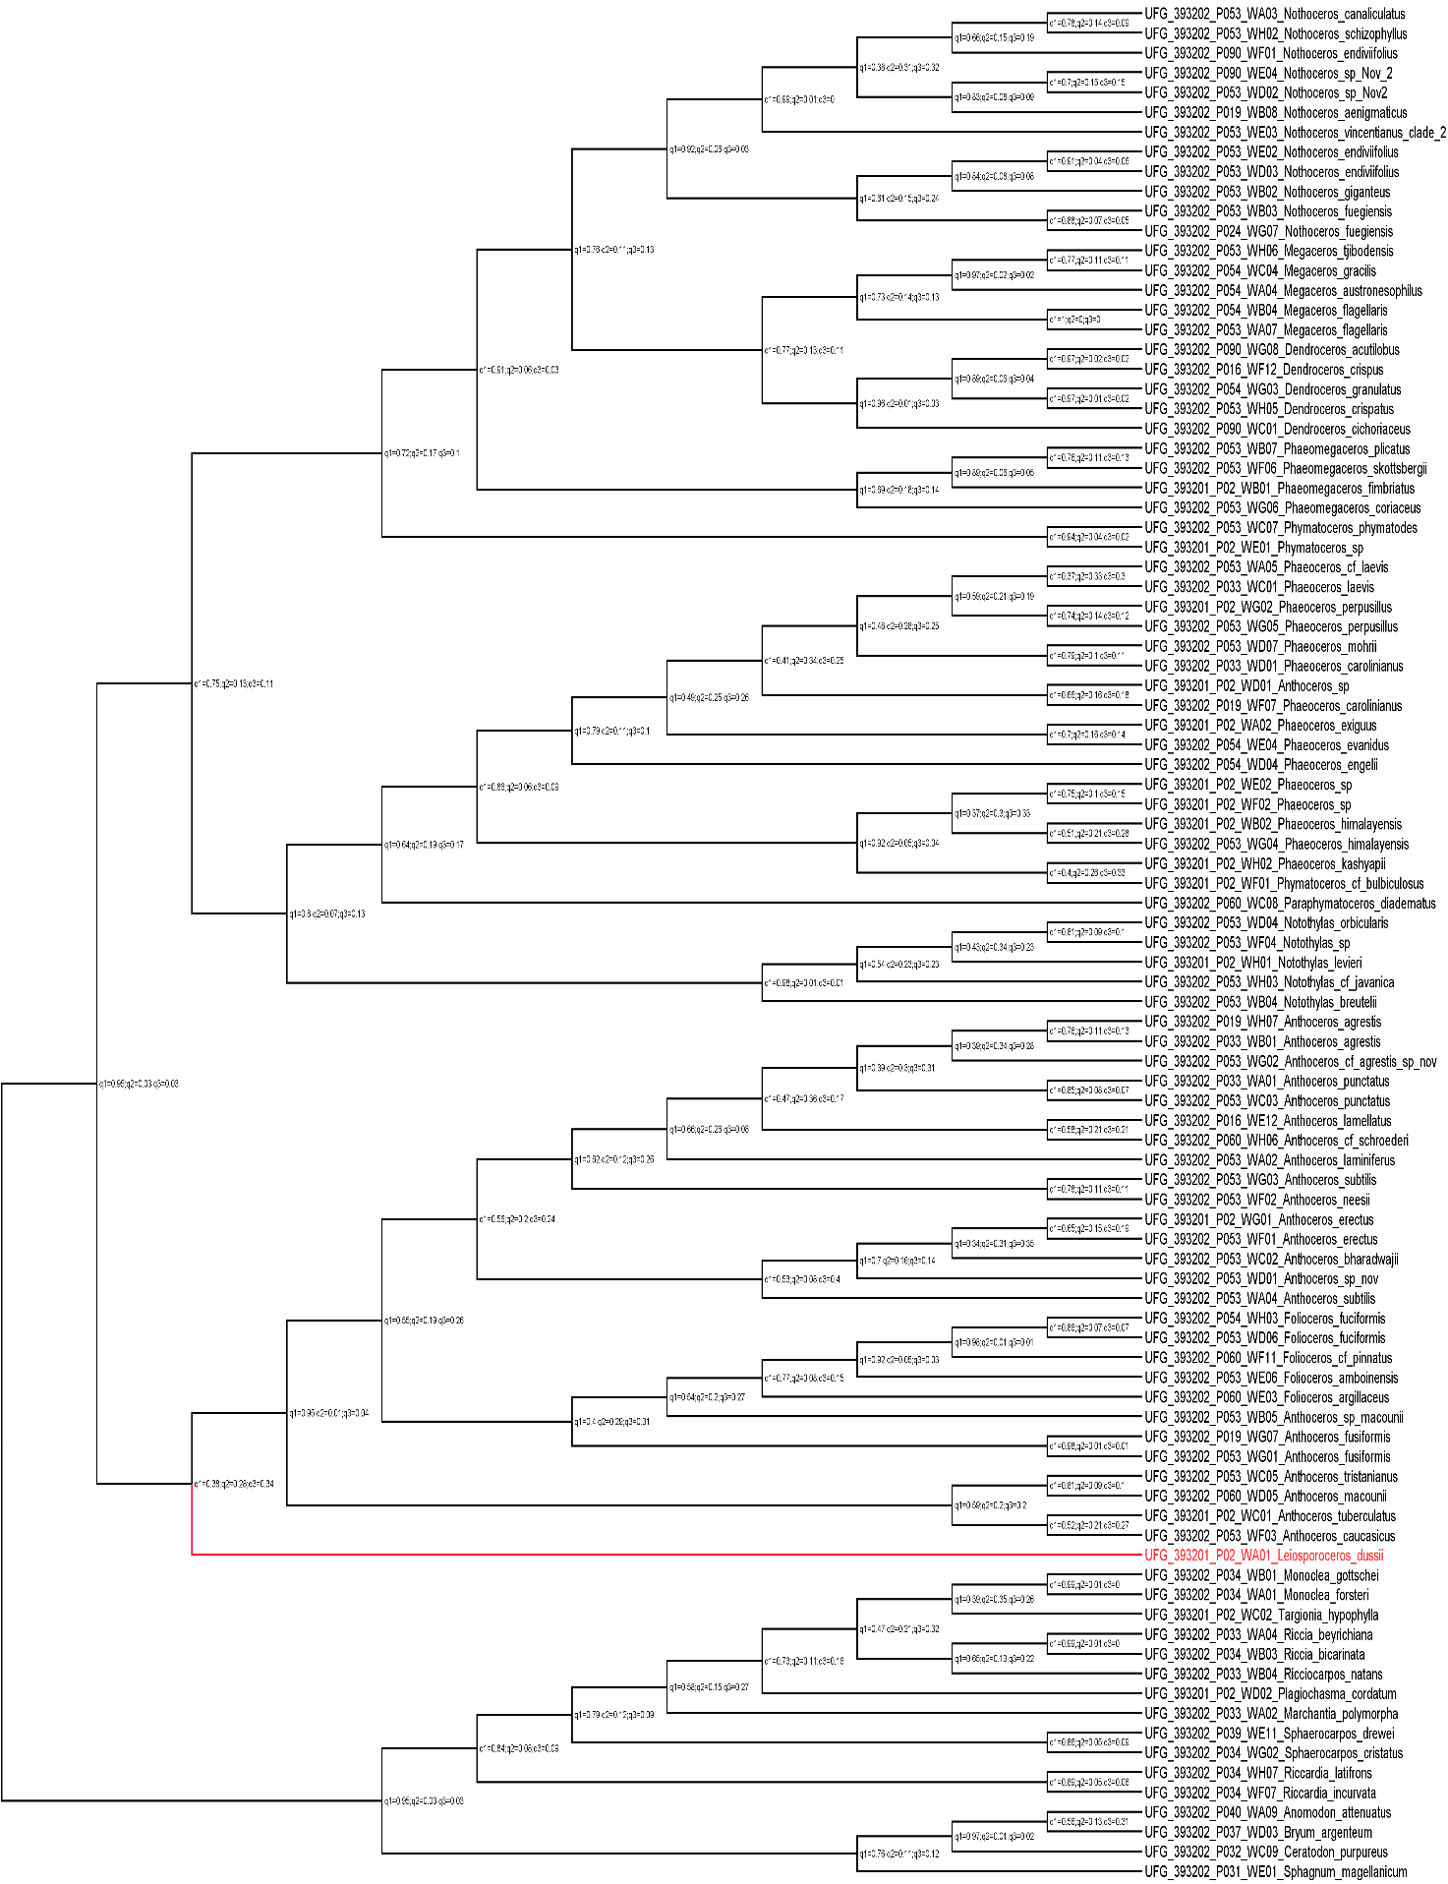

**Figure S20**. Hornworts phylogeny inferred with coalescence-based method (ASTRAL-III) from nucleotide data including the quartet values with 234 genes, for the three possible topologies, presented as percentages near the node (100/0/0).

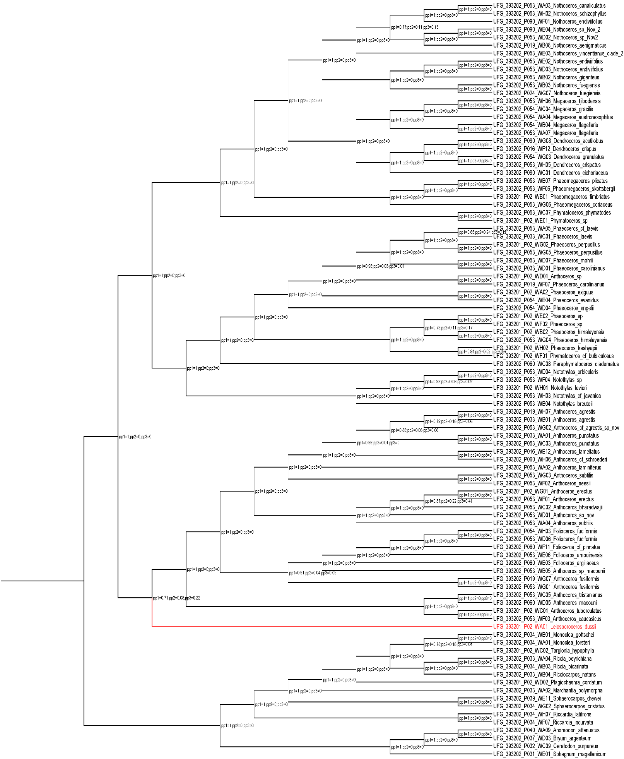

**Figure S21**. Hornworts phylogeny inferred with coalescence-based method (ASTRAL-III) from nucleotide data including the local posterior probability (lpp) values with 234 genes, for the three possible topologies, presented as percentages near the node (100/0/0).